**Important ITRS Changes from July 1st**

**Advice to Apple (IOS) Phone/Tablet Users**

**Good News!**

The ITRS is upgrading to improve the service from July 1st:

* Less chance of ITRS calls being dropped
* Direct access to the ITRS – no need for separate apps
* The same ITRS experience on phones, tables and PCs

For further details see ITRS.ie

**What Do You Need to Do?**

You just need to **take 3 simple steps** from July 1st.

**Step 1 - Get the New ITRS Chat Link**

The ITRS app will no longer work from July 1st.

If you have the ITRS app installed you should delete it on July 1st

From July ITRS will work through a direct link and you will need to save this to your phone.

* Go to ITRS.ie, scroll to and click on the ITRS launch button
* The ITRS will open on your screen as shown below

Click on the Safari Browser “Share” button browser options

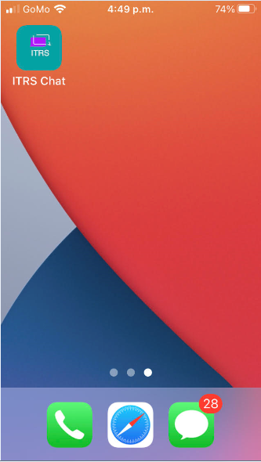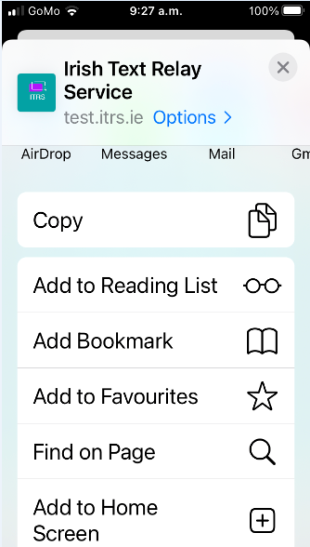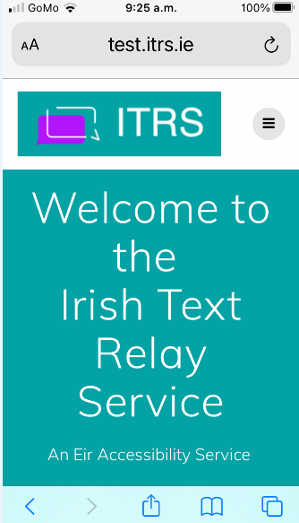

Then click on “Add to Home Screen”

Note: You may have to scroll to this option

The ITRS link will now appear on your home screen as “ITRS Chat”

**Step 2 - Register**

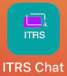Both new and existing users will need to register on the new ITRS. This is to ensure that your ITRS conversations are fully secure and confidential.

* Launch the ITRS by clicking on the new “ITRS Chat” Icon on your phone

or by clicking on the the ITRS launch button on ITRS.ie

* Follow the registration steps below

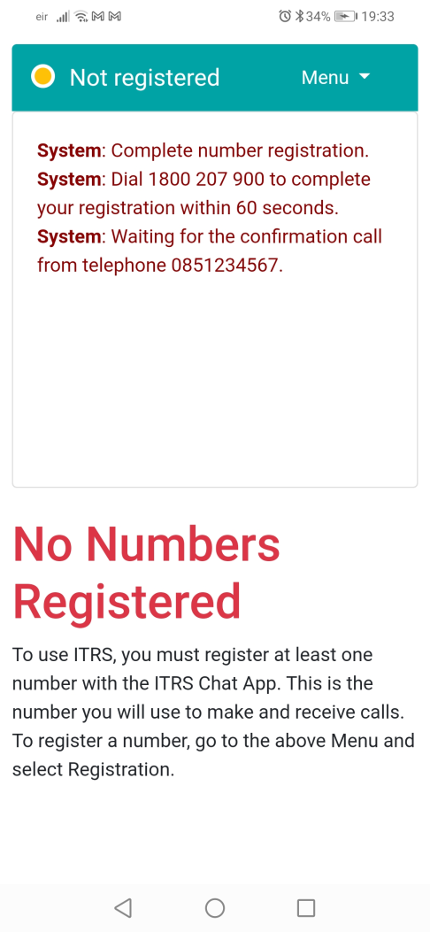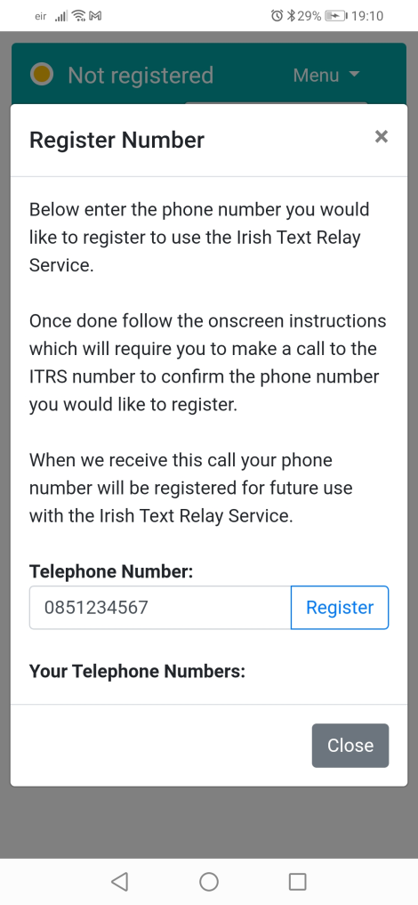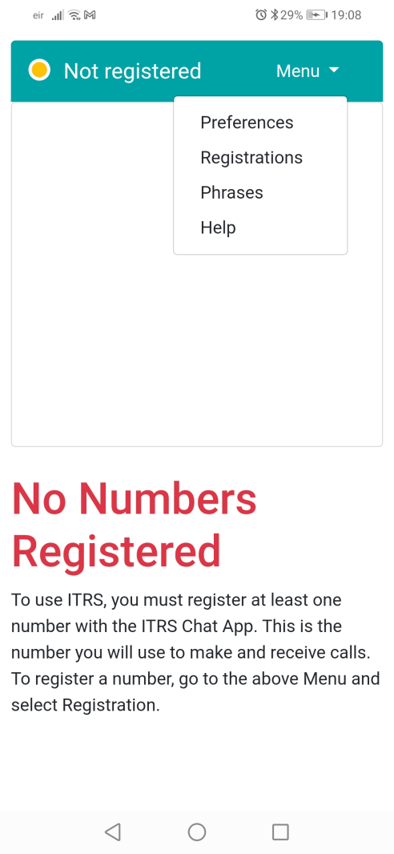

Enter your phone number and then click “Register”

Click on the ITRS Menu and then click “Registrations”

Then follow the System instructions to Call 1800 207 900 from your phone

**Step 3 – Save the Phone Number that Shows when ITRS Calls You**

* When the ITRS calls you it will no longer show as 076 692 1503.
* From July 1st these calls will show as 0818 555 777.
* Update your contacts by saving **0818 555 777** as “**ITRS Calling**” so that you can easily identify when ITRS calls you.

**Making and Receiving Calls**

When you have completed these steps, making and receiving calls on the new ITRS service will be exactly the same as before. Full instructions can be found on ITRS.ie.

**What if I Need Help?**

There is an updated Frequently Asked Questions (FAQ) section on ITRS.ie including ITRS contact details, if you need more help. You can also contact your local Chime Centre, see [www.chime.ie](http://www.chime.ie).